Syntax for all loops in shell scripting

**Solution:-**

If is statement that allows user to execute certain code based on whether the condition is True or False.

**SYNTAX**

If [CONDITION]

then

STATEMENT

else

STATEMENT

fi

Created an If script, providing execute permission to the script and running the script(script name is if_script.sh).

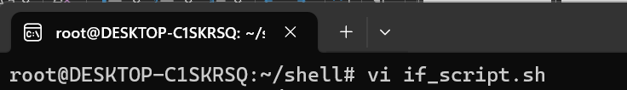

Below you can find the Program for if statement

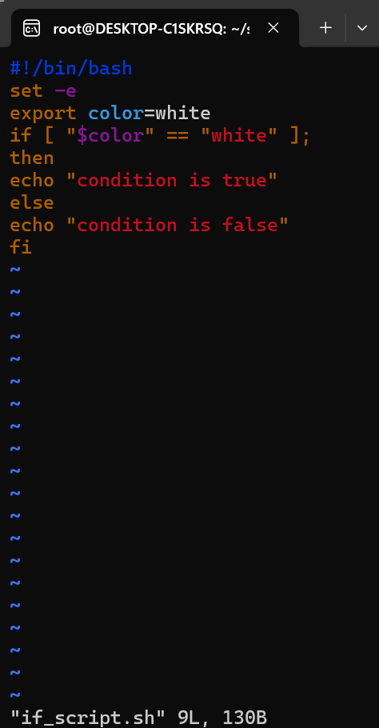

Provided execute permission to if_script.sh script and executed it

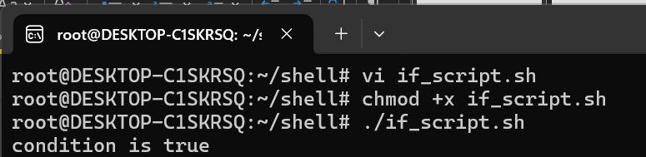

Condition satisfied; hence we received the output as condition is true.

**Elif condition**

elif condition is used to include multiple conditional expressions after the if condition or between the if and else conditions.

**SYNTAX**

If [CONDITION]

then

STATEMENT

elif [CONDITION]

then

STATEMENT

elif [CONDITION]

then

STATEMENT

else

STATEMENT

fi

Created an If script, providing execute permission to the script and running the script(script name is elif_script.sh).

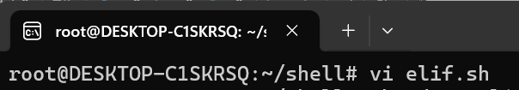

Below you can find the Program for if statement

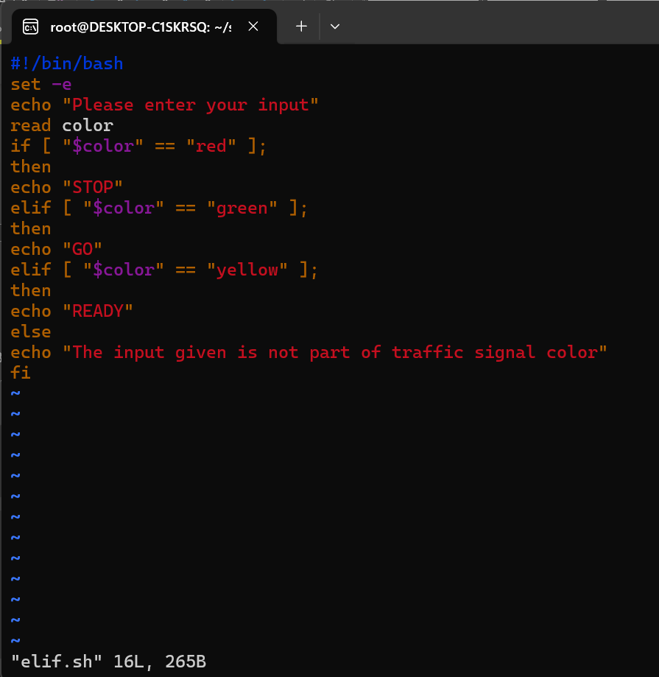

Provided execute permission to if_script.sh script and executed it

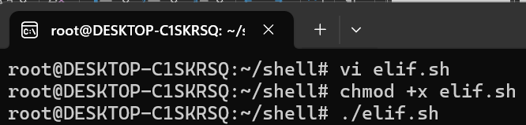

Condition satisfied; hence we received the output.

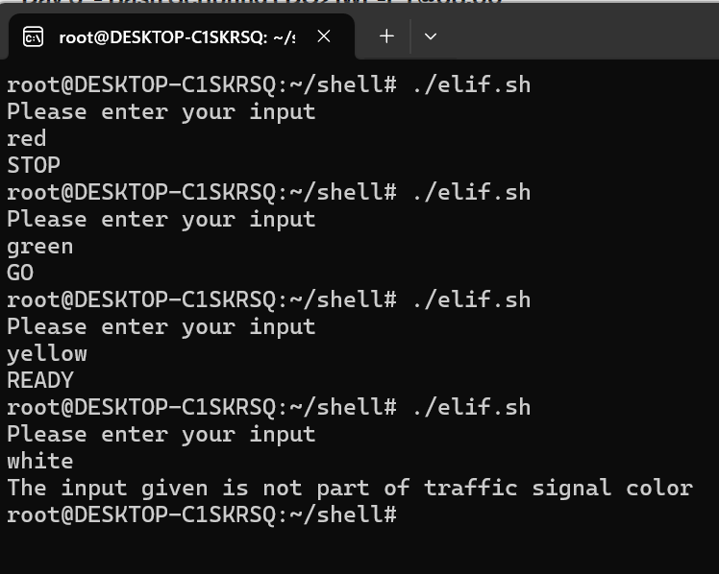

**For Loop**

For loop is a control flow statement used to iterate over a list of items.

**Syntax**

For VARIABLE IN LIST

Do

STATEMENT

Done

Created a For loop script, providing execute permission to the script and running the script(script name is for_loop.sh).

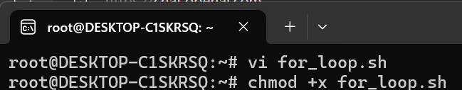

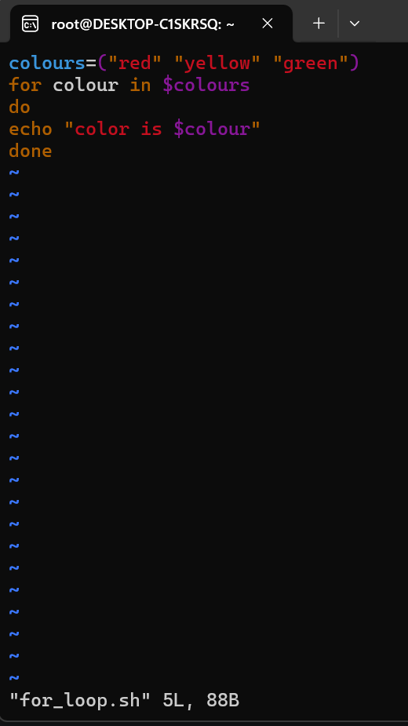

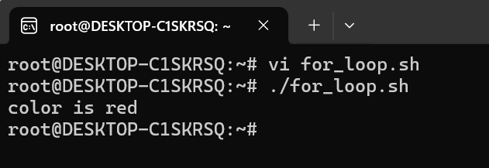

**While Loop**

While loop is another type of control flow statement used to repeatedly execute a block of code as long as a specified condition is true

**Syntax**

For CONDITION

Do

STATEMENT

Done

Created a While loop script, providing execute permission to the script and running the script(script name is while.sh).

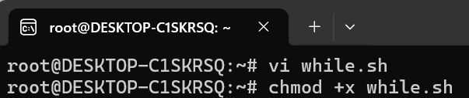

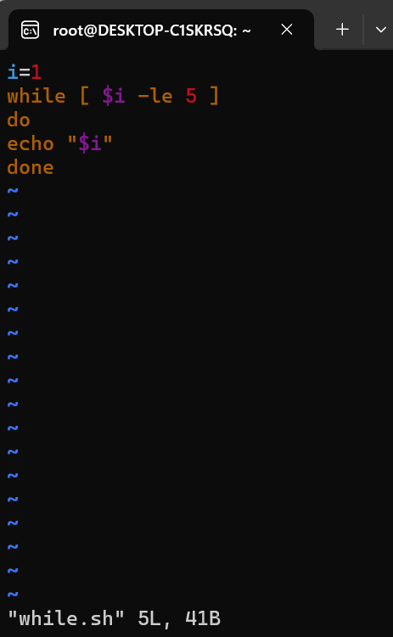

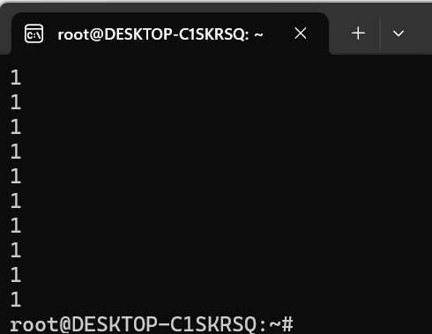

**Until Loop**

it executes its code block until a condition becomes true, whereas the while loop executes its code block as long as a condition is true.

**Syntax**

until [ condition ]

do

# Code block to be executed until the condition becomes true

done

Created a Until loop script, providing execute permission to the script and running the script(script name is until.sh).

